FRESH BITES CATERING

REPORT

INTRODUCTION:

1.1.OVERVIEW:

Fresh bites catering , a catering service, utilizes zoho books to manage their sales,track inventory,and handle invoicing. They can generate professional invoices for clients and track expenses related to ingredients and supplies. ZOHO books helps them maintain accurate financial records and streamline their catering operations.

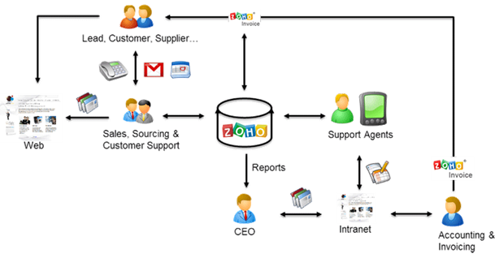

1.2.PURPOSE:

Fresh bites catering,a catering services,utilizes zoho books to manage their sales,track inventory,and handle invoicing. They can generate professional invoices for clients and track expenses related to ingredients and supplies.

USAGE:

ZOHO books is your one stop platform for managing your accounting tasks and orgainising your transactions. It a single secure location up with your company bills and invoices.reconcile your bank statements.control oversee projects and eliminate GST compliance worries.

PROBLEM DEFINITION & DESIGN THINKING:

i)Improving customer service

ii)ZOHO books streamlines customers grievence redressal

iii) Measuring the business impact

iv)Improves collaboration between teams

v)Access data at any time and form anywhere

EMPATHY MAP:

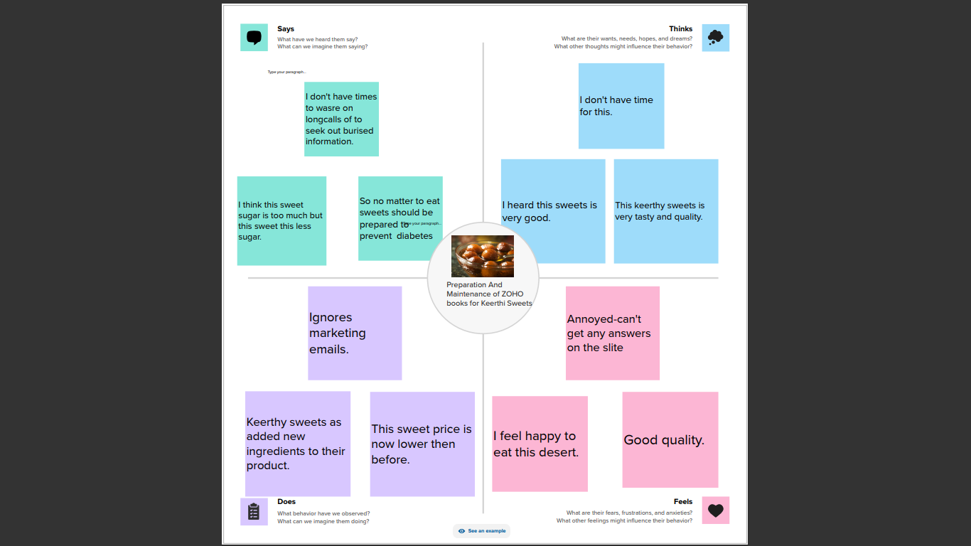

2.2.IDEATION & BRAINSTORMING MAP:

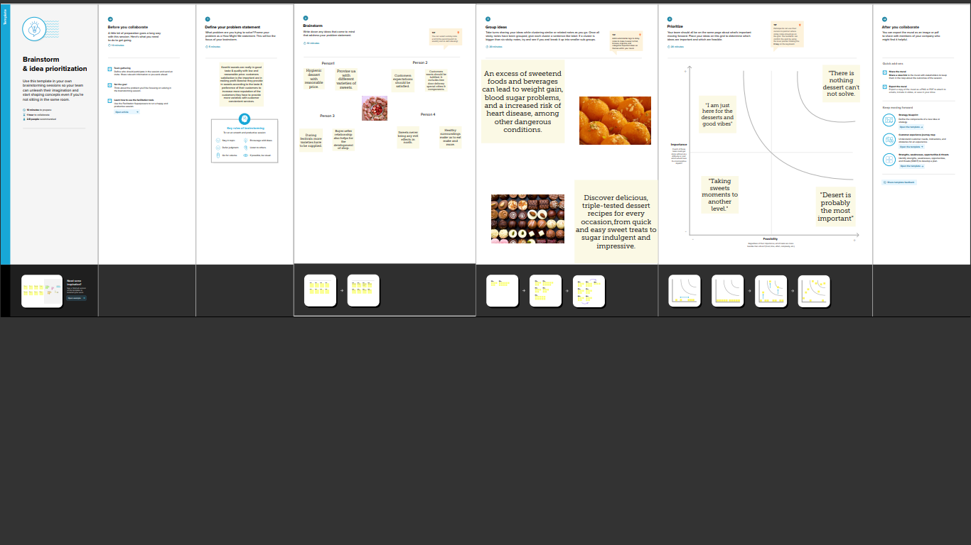

RESULT:

OUTPUT:

COMPANY NAME:Fresh bites catering(gayathri)

ITEM CREATION:

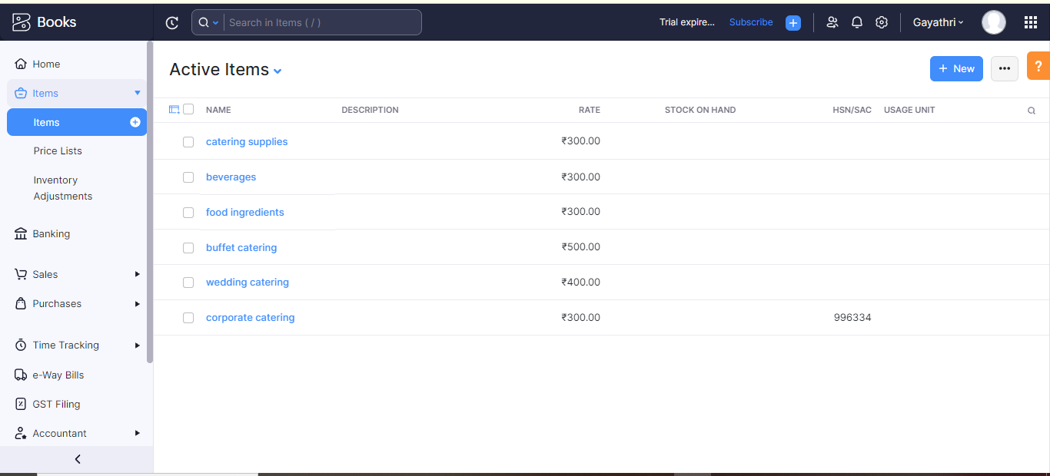

VENDOR CREATION:

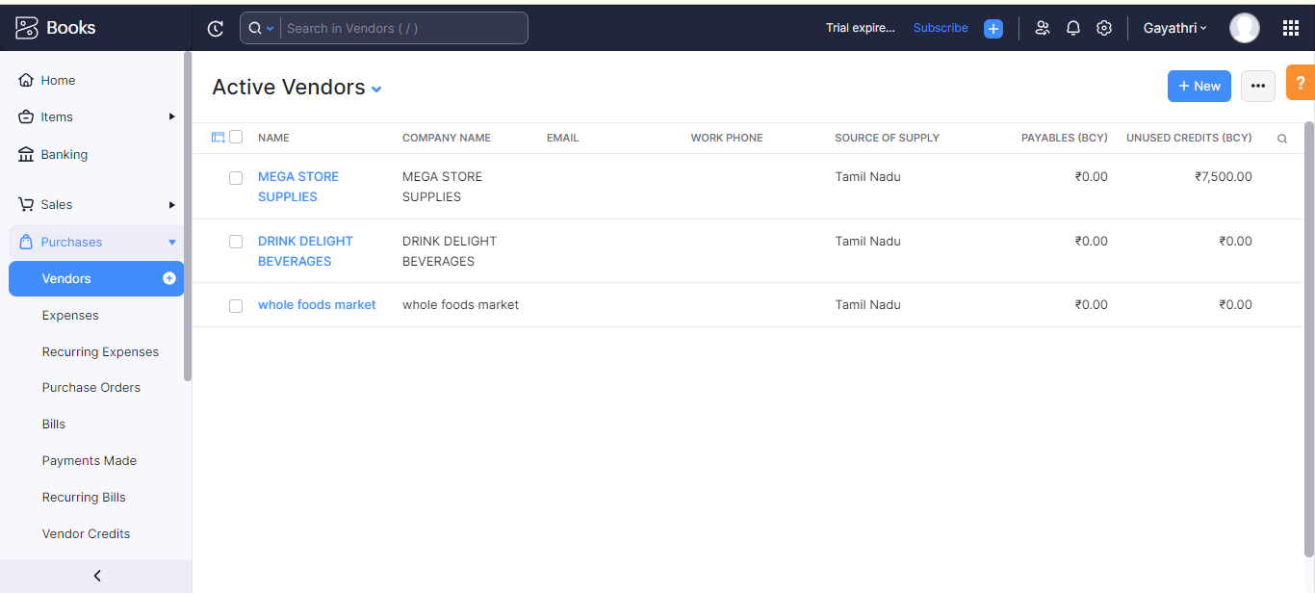

PURPOSE ORDER:

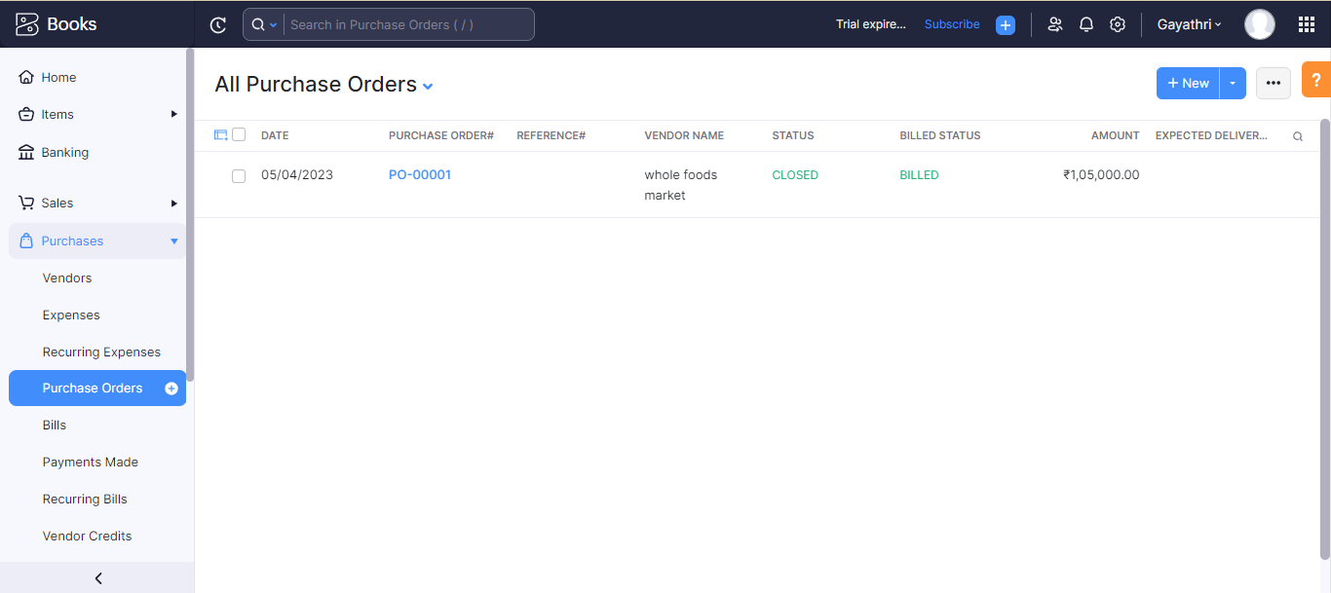

SALES ORDER:

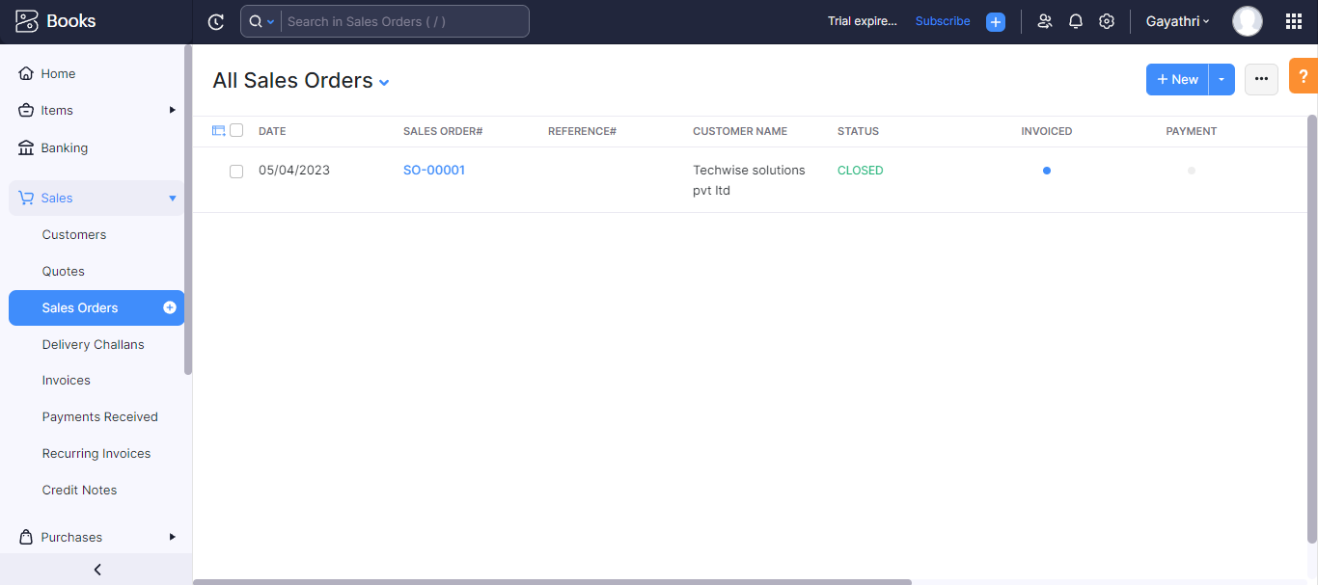

BANK TRANSACTIONS:

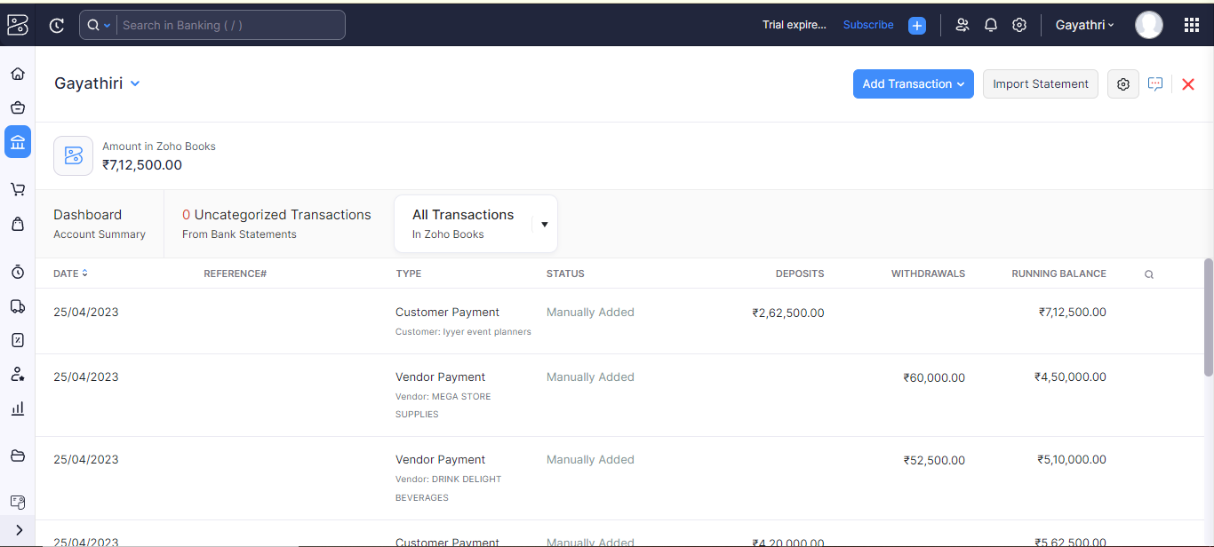

PROFIT AND LOSS ACCOUNT:

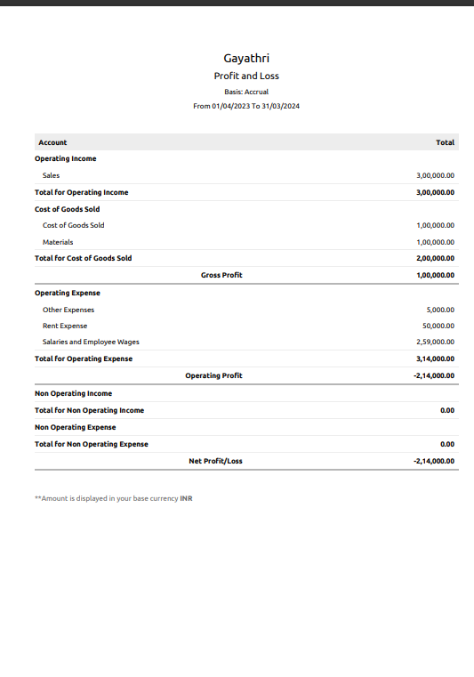

BALANCE SHEET:

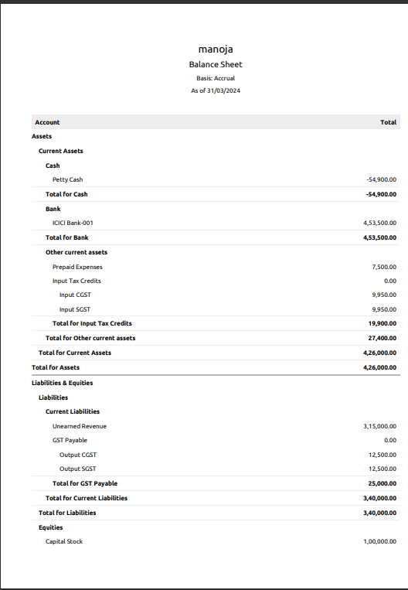

ADVANTAGES & DISADVANTAGES:

i)Monthly transactions cap

ii)Multiple subscriptions for multiple businesses

iii)Additional users require a fee

iv)No payroll services

v)Accounts payable limitations

CONCLUSIONS:

ZOHO books provides future technologies for going on business and supports students project.it is easy to use and access too.

FUTURE SCOPE:

The preference are in future useful the ZOHO books.

APPENDIX:

A Source data: COMPUTER DATA.

EMPATHY MAP&BRAINSTORMING:

<https://github.com/mtu121ucom019/preparation-and> mainteance-of-ZOHO-BOOKS-for-keerthi/commit/98c5ff7a09b2c0c9d2f39ccf638d3cb20ebcbd

ZOHO BOOK LINK:

Zoho.book.com